[KULBHUSHAN UPADHYAY]

(TOPS TECHNOLOGIES)

**Module (CSS and CSS 3) -2**

**Q. What are the benefits of using CSS?**

**ANS: Some benefits of CSS**

* Quicker page loads.
* An improved user experiences. CSS enables for user-friendly formatting in addition to making web pages attractive to the eye.
* Faster development times and simpler formatting adjustments simpler to update and manage.
* Better device compatibility and saves time.
* Aligning Design and Components Increased uniformity in the design.
* There are advantages to search engine optimization.
* The primary benefit of CSS is that it applies style uniformly to a range of websites. A single command can govern many HTML Pages.

**Q. What are the disadvantages of CSS?**

**ANS: Some Disadvantages of CSS**

* Learning Curve (browser compatibility).
* Developers become confused while using CSS, from CSS 1 to CSS 3.
* In CSS, some functions work in one browser may not always work in another browser. The web application must be tested for compatibility by the web developers using a variety of browsers.
* Security is in short supply.
* If the modifications emerge, we must verify their compatibility after making the necessary adjustments. All browsers are affected by a similar css update.
* Beginners and non-developers alike find the world of programming languages confusing. The various CSS levels, or CSS, CSS 2, and CSS 3, are often.

**Q. What is the difference between CSS2 and CSS3?**

**ANS:**

* Compared to CSS2, more browsers are compatible with CSS3.
* The standards for CSS3 are broken down into several separate modules, making it much easier to handle than CSS2, which was made up of a single page.
* Developers now add unique typefaces, such as those found in Typecast and Google typefaces, with CSS3. Prior to CSS2, Developers were limited to using "web-safe fonts" as they could be certain that the fonts they chose would always appear the same on all computers.

|  |  |  |
| --- | --- | --- |
| Parameters | CSS2 | CSS3 |
| Border Box Support | NO | YES |
| Selectors | Simple selectors | Advance selectors |
| Rounded Borders | NO | YES |
| Split Text Feature | NO | YES |
| Grid System and Template Layout | No | YES |
| Styling | Normal | Advance |
| Shadows | NO | YES |
| ANIMATION | NO | YES |

**Q. Name a few CSS style components.**

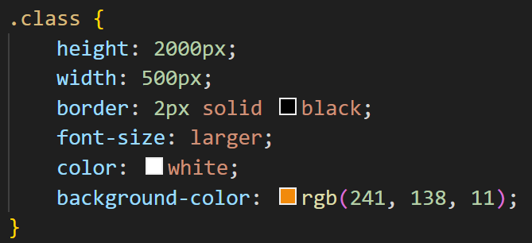**ANS***:*

* Height: 200px; (use for change height.)
* Width is the change in width of element.
* Border: To make a border and manage its thickness and type, and also to change the color of the border.
* Color is used for changes in font color.
* Background color is used to make a colorful background.

**Q. What do you understand by CSS opacity?**

**ANS**: The CSS opacity property is used to specify the transparency of an element. In a simple word, you can say that it specifies the clarity of the image.

* 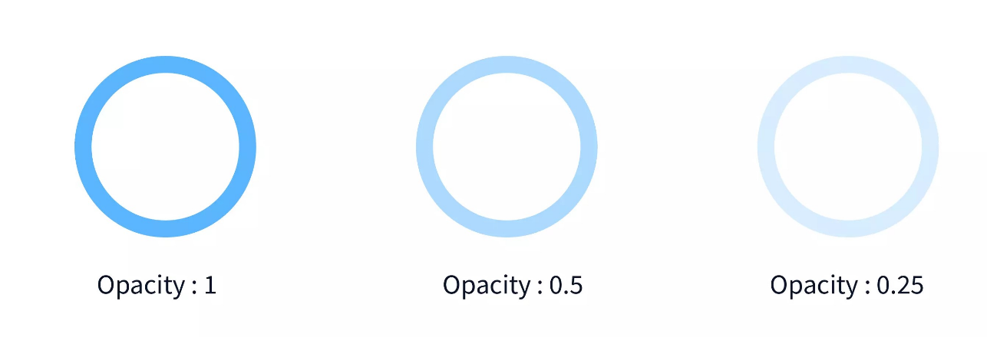Values for this property range from 0 to 1. If you set the property to 0, the styled element will be completely transparent.

**Q. How can the background color of an element be changed?**

**ANS:** The background-color CSS property allows you to modify the background color of a HTML element and any of its child elements.

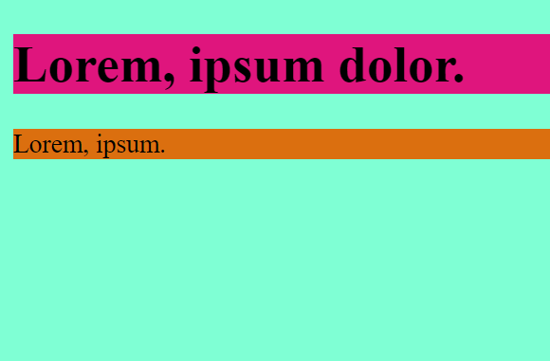Syn = background-color: red;

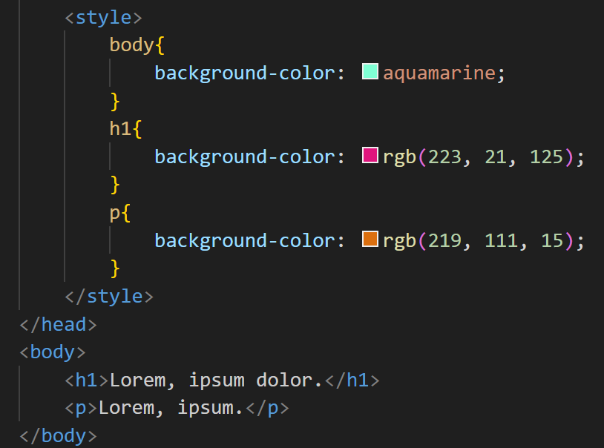

**Q. How can image repetition of the backup be controlled?**

**ANS:** CSS property for controlling image repetition in web pages is

* 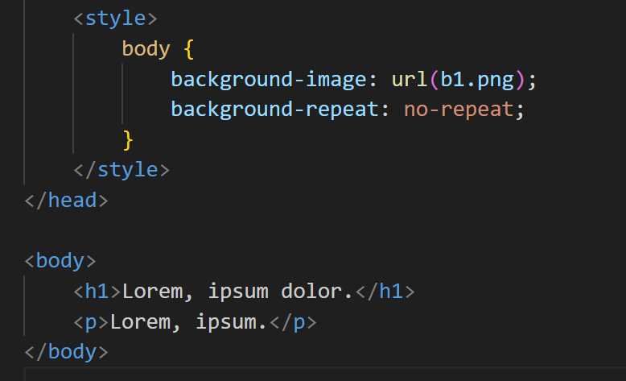Background-repeat: no-repeat;

In this example, the background-repeat property is set to no-repeat, which prevents the background image from repeating. This ensures that the image is displayed only once within the container element. Other possible values for background-repeat include repeat (default), repeat-x, and repeat-y, which allow the image to repeat horizontally, vertically, or both.

**Q. What is the use of the background-position property?**

**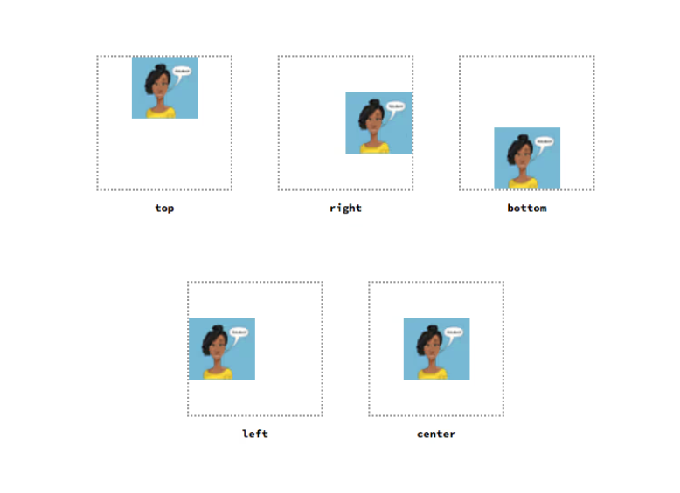ANS:** A web page's background picture can be positioned using the background-position. You can use % values or one of the following keyword values: top, left, bottom, or right.

A position defines an x/y coordinate to place an item relative to the edges of an element's box. It can be defined using one to four values. The first value represents the horizontal position, and the second represents the vertical position.

**Q. Which property controls the image scroll in the background?**

**ANS:** The type of attachment that the background picture has to its container is specified by the background-attachment property in CSS. To keep your background image fixed, you have to use the background-attachment property with the value fixed. Syntax: **background-attachment: fixed;**

[Values](https://developer.mozilla.org/en-US/docs/Web/CSS/background-attachment#values)

* [**Fixed**](https://developer.mozilla.org/en-US/docs/Web/CSS/background-attachment#fixed) = The background is fixed relative to the Parent.
* [**Scroll**](https://developer.mozilla.org/en-US/docs/Web/CSS/background-attachment#scroll) (default) = The background image scrolls along with the content as the user scrolls the webpage.
* **Local** = The background image scrolls with the element itself, rather than the entire webpage. This behaviour is particularly useful when the background is applied to a scrolling container rather than the entire page.

**Q. Why should background and color be used as separate properties?**

**ANS:** The background property is used to set the background color or image of an element, while the color property is used to set the text color of that element including headings, paragraphs, links, and other textual elements. They can also be used separately to create different effects. For example, you might want to set a background color for an element but leave the text color as the default.

* background-color: Specifies the background color of an element.
* background-image: Specifies an image to be used as the background of an element.
* background-repeat: Controls how the background image is repeated.
* background-size: Defines the size of the background image.
* Color: Specifies the text color of an element.

**Q. How to centre block elements using CSS1?**

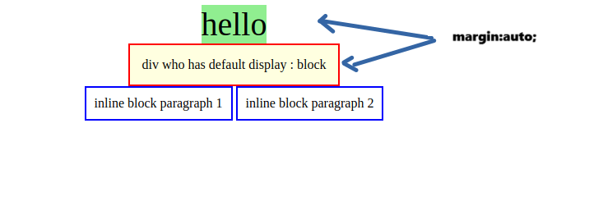**ANS.** Utilizing the margin attribute, center the block components. For it to appear centered, we must set the margin from left to right. Having just one property value, "auto," which sets the margin automatically to center our block element, eliminates the need for us to perform this task manually.

**Q. How to maintain the CSS specifications?**

**ANS:**  The specification defines how CSS properties should be implemented by browser vendors, along with detailed code samples and other information.  
The specifications include the syntax and data types of the language.

* Understand the Box Model: Have a thorough understanding of the CSS box model, which defines how elements are rendered on the web page. This includes properties like width, height, padding, border, and margin. Follow the specifications and use them correctly to ensure consistent rendering across different browsers.
* Validate Your CSS: Use CSS validation tools to ensure your stylesheets are error-free.
* The syntax and data types of the language.
* A detailed explanation of CSS selectors.
* The cascade sheets. (the "C" in CSS).
* The specification also specifies how stylesheets can be included in your web document and how to target specific media, e.g., print or screen.

**Q. What are the ways to integrate CSS as a web page?**

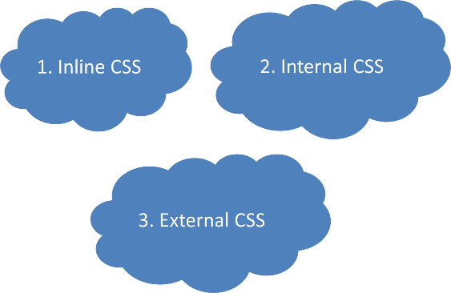 **ANS:** There are 3 ways to integrate CSS on a web page.

1. ***Inline CSS*** = Just what its name suggests—that is, in a line. The element to which we wish to apply inline CSS is utilized within. For applying a specific style to a tag.

**<**[**h1**](https://webplatform.github.io/docs/html/elements/h1)[**style**](https://webplatform.github.io/docs/html/attributes/style)**="[color](https://webplatform.github.io/docs/color" \t "_blank): blue;">This is the INLINE CSS EAXMPLE.</**[**h1**](https://webplatform.github.io/docs/html/elements/h1)**>**

1. ***Internal CSS*** = Internal CSS is used in the same HTML file inside the <style> tag in the head. Internal CSS has less priority than inline CSS but is higher than external CSS. In internal CSS, we have to use the selector, class, and ID to apply CSS to the HTML element.

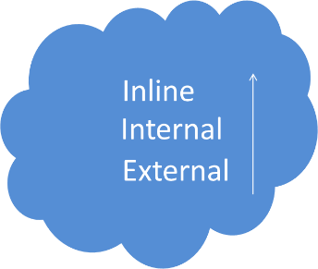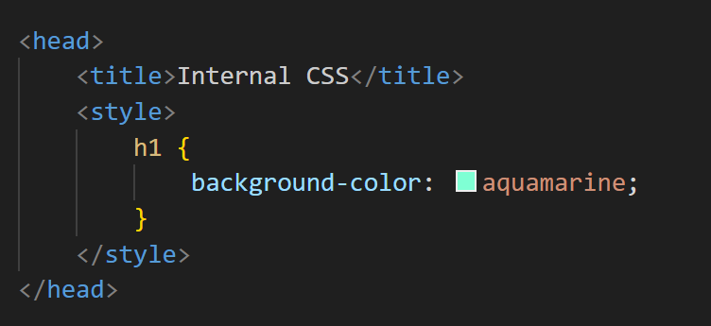

1. ***External CSS***: External CSS is the most preferred way to use CSS in HTML. Selectors are also used in external CSS to refer to HTML elements. Link the CSS file in the HTML file with the <link> tag in the head section, and the external file extension is =.css.

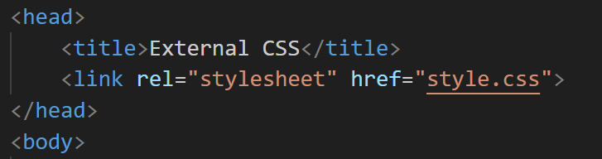

**Q. What are embedded style sheets?**

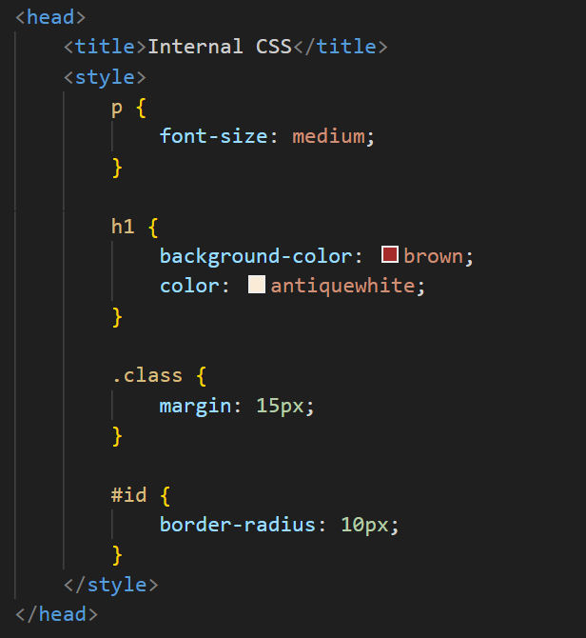**ANS: *Embedded Stylesheet:*** It enables you to provide all of the styles for an HTML document in a single file. Insert in <style> </style> tags with the CSS attributes into the <head> section of the HTML. (Internal style CSS is another name for embedded style sheets.)

* Embedded style sheets have the advantage of loading instantly with the page. In terms of download speed and performance, this method can be useful.

**Q. What are the external style sheets?**

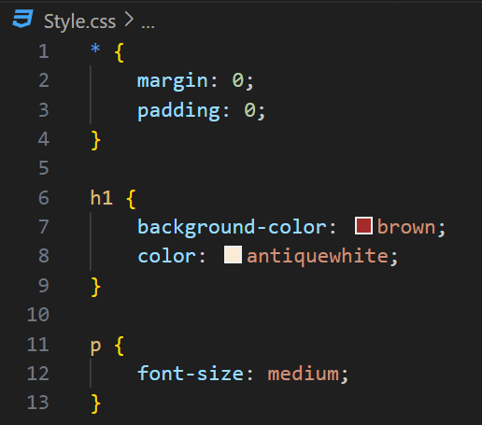**ANS: *External CSS***: When we write CSS in an external file and add the link to that file to the HTML file, that is known as external CSS. External CSS is the most preferred way to use CSS in HTML. Using external CSS makes the file load faster, and CSS gets loaded first and then the HTML content gets loaded. Selectors are also used in external CSS to refer to HTML elements. Link the CSS file in the HTML file with the <link> tag in the head section, and the external file extension is = .css.

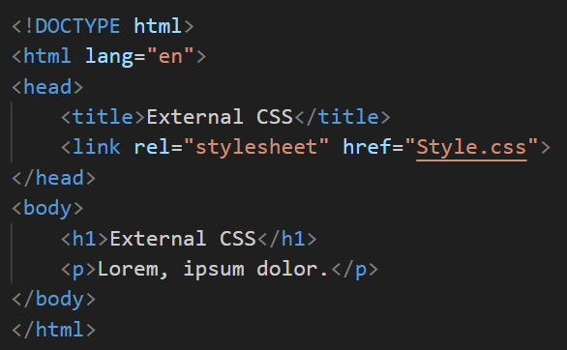

**Q. What are the advantages and disadvantages of using external style sheets?**

**ANS: *The Advantages of External-Style Sheets Are as Follows:***

* Using External Style, the styles of multiple documents can be controlled from one file.
* Classes can be created for use on multiple HTML element types in many documents. In complex situations, selector and grouping methods can be used to apply styles.
* Separation of content and presentation: An external style sheet allows you to separate the content of your website (HTML) from the presentation (CSS). This makes it easier to maintain and update your website, as you only need to change the style sheet rather than making changes to the HTML of each individual page.
* Improved performance: An external style sheet is only loaded once, even if it is used on multiple pages.
* SEO-friendly − You reduce the quantity of HTML code. One particular advantage is SEO. The website's clean code will eventually raise its position in search results.

***The Disadvantages of external style sheets are as follows:***

* With CSS, what works with one browser might not always work with another. The web developers need to test for compatibility, running the program across multiple browsers.
* In order to import style information for each document, an extra download is needed.
* CSS, from CSS 1 up to CSS 3, results in confusion among web browsers.
* There is a scarcity of security.
* Additional HTTP request: An external style sheet requires an additional HTTP request to load, which can slightly increase the time it takes for the page to render.
* Harder to override: It can be harder to override the styles in an external style sheet, as they are applied globally. To override a style, you need to use more specific selectors or use the “!Important” declaration, which can make your style sheet more complex and difficult to maintain.

**Q. What is the meaning of the CSS selector?**

**ANS:** A CSS selector is the first part of a CSS rule. It is a pattern of elements and other terms that tell the browser which HTML elements should be selected to have the CSS property values inside the rule applied to them.

1. **Universal Selector** = The asterisk (\*) is the universal selector in CSS. By default, it selects all elements in a Holl document.
2. **Element Selector** = The element selector selects the HTML element by TAG.Ex. h1 { Color: blue;}
3. **Class Selector** = "A class selector selects all elements that have a given class name.

* For example = .index would select any element that has a class of “index”. The class selector is introduced by (.) A class name should not start with a number.
* <h1 class=" index "> Blue</h1>"
* **CSS** = . index {color : blue}

1. **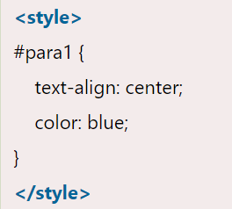ID Selector** = The id selector selects the id of an HTML element to select a specific element. An id is always unique in the page, so it is chosen to select a single, unique element. It is written with the hash character (#).

* <p id="para1">Hello I am KB </p>

1. **Group Selector** = The grouping selector is used to select all the elements with the same style definitions. A grouping selector is used to minimize the code.

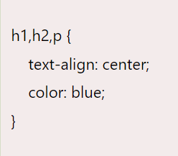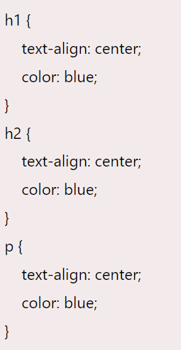

1. [**Attribute selectors**](https://developer.mozilla.org/en-US/docs/Learn/CSS/Building_blocks/Selectors#attribute_selectors) = This group of selectors gives you different ways to select elements based on the presence of a certain attribute on an element.

<a href="http://Google.com">Google</a>

CSS = A [href = Google] {color:orange;}

1. [**Pseudo-classes and pseudo-elements**](https://developer.mozilla.org/en-US/docs/Learn/CSS/Building_blocks/Selectors#pseudo-classes_and_pseudo-elements) = This group of selectors includes pseudo-classes, which style certain states of an element. The :hover pseudo-class for example selects an element only when it is being hovered over by the mouse pointer.
2. **Descendant Selector** = The descendant selector matches all elements that are descendants of a specified element.

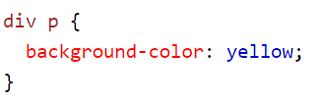

1. **Child Selector (>)** = The child selector selects all elements that are the children of a specified element.

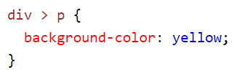

**Q. What are the media types allowed by CSS?**

**ANS:** Media queries can be used to check & set layout for many things, such as:

* Width and height of the device
* Orientation (for tablet or phone in landscape or portrait mode)
* Using media queries is a popular technique for delivering a tailored style sheet to desktops, laptops, tablets, and mobile phones (such as iPhones and Android phones).

*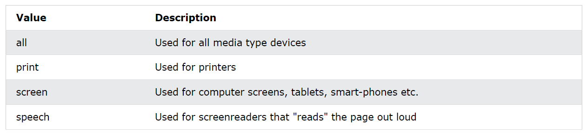*

**Q. What is the rule set?**

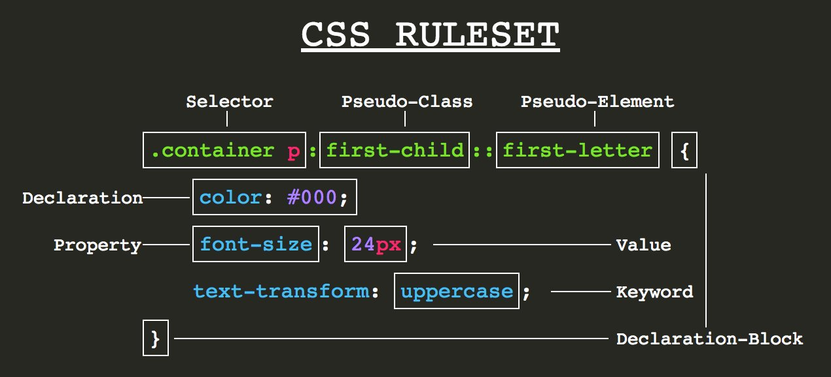**ANS: *Rule set****: A controlled interface uses a table of instructions to decide what data is acceptable and how it should be handled between linked systems.*

* The complete declaration is a rule set.
* The .container is a selector. The id selector, denoted by a hash(#), used to apply the property having the unique id. The second is a class selector denoted by a dot(.), used to select all elements that belong to a particular class attribute.
* The key/value pair, which is separated by a colon in between and ends with a semi-colon, is a declaration.
* The key is property name, and the value is property value; both the key and values are case-insensitive by default in CSS.
* 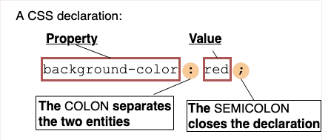The portion in which the curly braces and the properties are declared is the declaration block.

**Q. Create Layouts**

**ANS:**

[**https://github.com/kbu09/CSS\_ASSIGNMENT-/tree/main/CSS%203**](https://github.com/kbu09/CSS_ASSIGNMENT-/tree/main/CSS%203%20)

**Pending Questions from Assignments – 1**

**Q. What is the ‘class’ attribute in HTML?**

**ANS:** The class attribute is part of the [global](https://www.w3schools.com/tags/ref_standardattributes.asp) attributes and it can be used on any HTML element multiple times.

* The class attribute specifies one or more class names for an element. The class attribute is mostly used to point to a class in a style sheet.
* In HTML, the "class" selector is used to select an element with a specific class attribute. The class selector starts with a period (.) followed by a class name. Unlike the id selector, we can attach multiple selector to an HTML element. The important point to note about the class selector is that the class name must not be started with a number.

**Q. What is the difference between the ‘id’ attribute and the ‘class’ attribute of HTML elements?**

|  |  |  |
| --- | --- | --- |
| **KEY** | **ID** | **CLASS** |
| Syntax | In HTML, for an element, the ID name starts with the "#" symbol followed by a unique name assigned to it. | "Class" assigned to an element has its name starts with "." followed by class name. |
| Selector | Only one ID selector can be attached to an element or HTML Body. | Multiple class selectors can be attached to an element. |
| Uniqueness | ID is unique in a page and can only apply to at most one element. | The class can be applied to multiple elements so it could be multiple times on a single page. |

**ANS.**

**Q. How are active links different from normal links?**

**ANS. Normal Links**

* A hyperlink in HTML that has not yet been clicked by the user is referred to as a Normal link. The Normal links will by default have an underline and be colored blue. However, we may alter the look by utilizing the CSS properties (a:link).

**Active Links**

* Any hyperlink that is being used by the user at that moment is called an active link. The link is in an active state whenever the user keeps down the mouse button on it without releasing it, or if they right-click on it, it turns red.
* Once the user releases the mouse button, the active state disappears momentarily. The CSS attributes (a:active) allow us to alter the appearance of the active links, though.

\*\*\*\*\*\*\*\*\*\*\*\*\*\*\*\*\*\*\*\*\*\*\*\*\*\*\*\*\*\*\*\*\*\*\*\*\*\*\*\*\*\*\*\*\*\*\*\*\*\*\*\*\*\*\*\*\*\*\*\*\*\*\*\*\*\*\*\*\*\*\*\*\*\*\*\*\*\*\*